const int LED_PINS[] = {2, 3, 4, 5, 6, 7, 8, 9};

bool areLedsOn = false; // Variable to track if LEDs are currently on

void setup() {

Serial.begin(9600); // Initialize the serial monitor

// Set LED pins as OUTPUT

for (int i = 0; i < 8; i++) {

pinMode(LED_PINS[i], OUTPUT);

}

}

void loop() {

// Loop through decimal values from 0 to 255

for (int decimalValue = 0; decimalValue <= 255; decimalValue++) {

// Display binary representation of the decimal value on LEDs

displayBinary(decimalValue);

// Output the decimal value to the serial monitor

Serial.println(decimalValue);

// If decimal value reaches 256

if (decimalValue == 256) {

// Toggle LED states

if (!areLedsOn) {

turnOnAllLeds();

areLedsOn = true;

Serial.println("Reached 256. All LEDs are ON.");

delay(100); // Keep LEDs on for 100 ms

} else {

turnOffAllLeds();

Serial.println("All LEDs are OFF.");

while (true) {

// Infinite loop to stop the program

}

}

}

delay(500); // Adjust the delay to control the speed of counting.

}

}

void displayBinary(int decimalValue) {

// Display binary representation of decimal value on LEDs

for (int i = 0; i < 8; i++) {

int bitValue = (decimalValue >> i) & 0x01;

digitalWrite(LED_PINS[i], bitValue);

}

}

void turnOnAllLeds() {

// Turn on all LEDs

for (int i = 0; i < 8; i++) {

digitalWrite(LED_PINS[i], HIGH);

}

}

void turnOffAllLeds() {

// Turn off all LEDs

for (int i = 0; i < 8; i++) {

digitalWrite(LED_PINS[i], LOW);

}

}

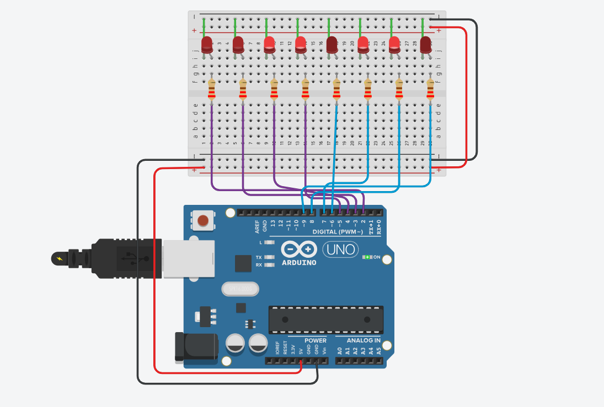

Link in TInkercad:

https://www.tinkercad.com/things/bwyq6GN9aVA-funky-jarv/editel?sharecode=8XLniHgNaSzfW_8hZZUAdSPwQsohYw0fD2ac0-UCGdI